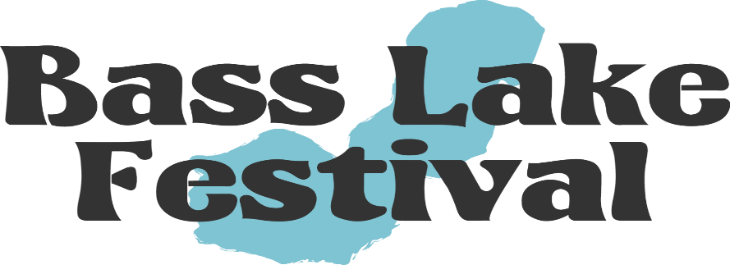
July 28th-30th, 2023
The Bass Lake Festival invites you to become a partner with us to promote our beautiful lake community with the Bass Lake Festival. As we celebrate 156 years of all things Bass Lake, please consider sponsoring the festival as a general donation or you can sponsor a specific event! As a sponsor, your name/ business name will be linked in our advertising efforts via radio, newspaper, festival website, sponsor wall and specific events that you sponsor.
Ways you can help sponsor our festival is by donating Gift Baskets, Gift Cards, Raffle items, or Monetary Donation. We can pick up any donation items.
Your sponsorship will help assure the success of our long-standing Bass Lake Festival!
Please check out our events Page on Basslakefest.com or you can find us on Facebook “Bass Lake Festival”
If you have any Questions, contact Jennifer Humpfer @ (219)331-8703 Or Rocha32790@gmail.com
Thank you
Bass Lake Festival Association
Jennifer Humpfer, Tami Stout, Mary Topelian, Kathy Linkus
--------------------------------------------------------------------------------------------------
Name ____________________________ Phone _____________________
Address_______________________________________________________
Donation Amount__________________ Event ______________________
Donation Item ______________________ Need item Picked up? ________
* Please visit our website for all events : www.basslakefest.com
Mail This Form with check payable to: BLF, PO Box 455, Knox, IN 46534
THANK YOU FOR YOUR GENEROUS SUPPORT!

